WOYO 12V24V CAN Bus Circuit Tester 16Pin Break Out Box Detection CAN Tester Vehicle Diagnosis On-Board Diagnostics Tester
This is a CAN circuit tester that compatible with 12 and 24 volt systems, 16 pins design can achieve quick connect when during the vehicle maintenance diagnosis. If you are looking for this tool, come and have a try, it will not let you down.
1.CAN Tester Box is a CAN Bus circuit tester compatible with 12 and24 volt systems;
2.Testing DLC (OBD port) if any error before connecting connecting other diagnostic equipment to DLC, such as pin short circuit and polarity reverse connection ;
3.Real-time display of communication signals ( such as communication protocol signals ) on the allocated pins which can quickly locate faults and replace the voltage measurement function of digital multi-meter ;
4.Fastly connect 16 pins during vehicle maintenance diagnosis;
5.Monitoring input voltage of OBD when burning module, high and low voltage alarm;
6.Quick short obd porsche communication 3-7;
Short-circuit obd VW key all lost 1-6;
Short-circuit obd Mitsubishi remote control 1-4;
Short-circuit obd Toyota sync 4-13;
7.OBD workbench CAN boot box;
8.Replace the battery tool;
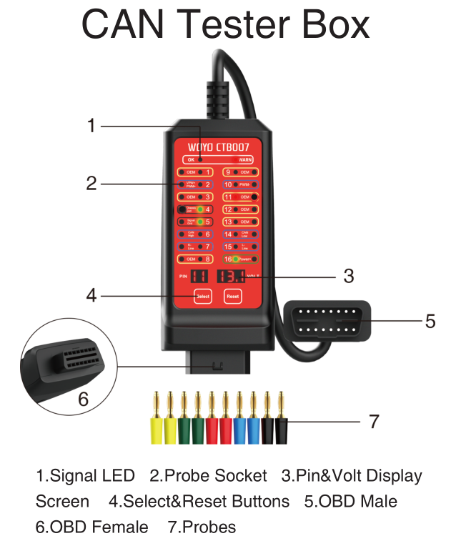
Specifications:
Input Voltage:9.0-32.0VDC
Maximum Load:2.0A
Resolution:0.1V
Overload Protection:Yes, PTC Fuse (Self-Healing)
Reverse Polarity Protection:Yes,LED On Pin 4&5 Turn Red
Protocol Standard:PWM(J1850)、VPW（J1850）、ISO 9141-2、DIS/ISO 14230-4、CAN(J-2284)
Operating Temperature:0℃-50℃，Humidity<70%
Banana Socket:16P*2.0mm
OBD Cable Length:70cm(27.5inch)

Packing list:
1 * CAN Bus Circuit Tester

